**MBC Occupancy Manual Content from Tami Chin**

**Graham comments/questions in yellow**

EQUIPMENT & FURNISHINGS

* Shared Work Spaces MALIA DID THIS SECTION (Though assigned to you12 Different? Combine?

See her version

* + Multi-disciplinary Workroom
    - Conference-style type room, located on the VNC patient care floors that can be used for small group meetings, education sessions.
    - Typically accommodates ~10 people sitting around a rectangular conference table
    - AV capability – large wall monitor with projector capability
  + Inter-disciplinary Workroom
    - Individual computer workstations in a shared workroom environment. Workstations are to be used for patient care providers, while providing patient care on the respective patient care floor. Workstations are not to be “claimed” for any specific individual use.
    - Shared workspace environment etiquette is enforced
      * Quiet workspace
      * no eating
      * clean up after yourself
  + Conference Room SHOULDN’T THIS BE IN Shared Building Features and combined with the Conference room section that appears below?
    - Conference Rooms are available on the patient care floors for patient care team use.
    - Oversight and scheduling of these rooms lie with the Nurse Manager.
    - In general, these can be used for small classes, inservices, department meetings
  + Consult Room SHARED BLDG FEATURES SECTION?
    - Room that patient care providers can use for private conversations with patient family member(s) and/or significant other.
    - Room is to be cleaned up after use.
    - Lock – key with nurse manager
  + Family Room SHARED BUILDING FEATURES SECTION?
    - Public area for family members to sit and gather, outside the patient room
* Staff lockers
  + Staff lockers are available for day use.
  + Locker assignments and specific use of lockers will be managed by the department manager.
  + Lockers on patient care floors can be shared with other patient care staff who come onsite to provide patient care.
* Conference Rooms SHARED BLDG FEATURES SECTION?
  + There are conference rooms on the 1st and 2nd floors, available for hospital and public use.
  + Reservations are available online through Event Management System (EMS)
  + Each room is equipped with large monitors and projectors
  + Rooms will be locked after hours, by Security, and re-opened by Security
  + There will be video displays outside of these rooms that will provide meeting schedule
  + 4 Conference Rooms
    - Room 1600
    - Room 1602
    - Room 1600+1602
    - Room 2910

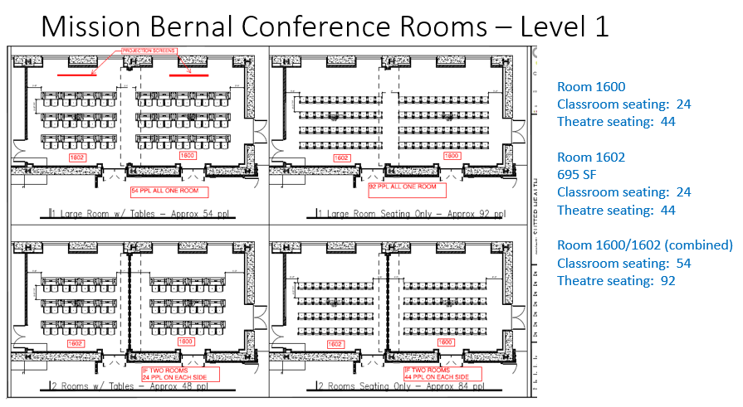

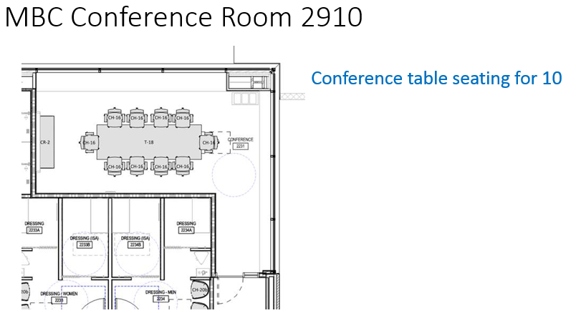

* On-Call Rooms
  + There are 2 non-dedicated on-call rooms: 5361, 5359
  + Contact Support Services to reserve an on-call room (up to 1 week in advance). This can be done via …
    - Call x77900 (415.600.7900)
    - Log-on to Online room scheduling portal and reserve
    - Requestor will receive an email confirmation
  + After hours requests can be directed to either PBX (Telephone Operator) or Nursing Supervisor for “same day” request
* Staff Lounges
  + For use by non-physician staff who work on the respective patient care floor
  + Nursing staff are responsible for cleaning the coffee maker
* Table of contents also has line item called Special Events – assigned to you. Not sure what this means- catering?
* Employee ID Badges
  + Staff need to touch their badge to the respective device, in order to activate the corresponding system

DEPARTMENTS

* Departments (floor by floor)

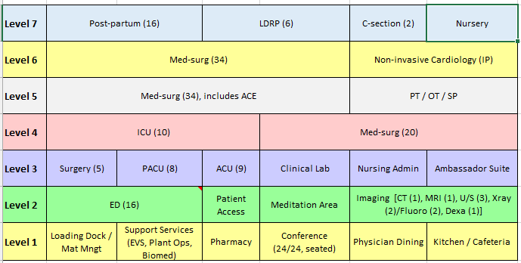

* Support Services

WHAT INFO IS NEEDED HERE? DONTKNOW, unless description, location and contact info for housekeeping, engineering, safety office, volunteer office, transport, etc. I don’t see these referenced anywhere else. May show up as Important Contacts –i.e. just phone numbers., but I don’t know if Lisa plans to include

BUILDING WIDE ELEMENTS

* Nurse Call System

The Nurse Call Rauland Responder 5 system is an application which enables the patient to alert staff from the bedside, among other patient locations. The system utilizes devices at the bedside and in the patient room to accomplish these important notifications. The Nurse Call Rauland Responder 5 system has THREE primary functions:

1. It serves as a code required system for patient safety & security.
2. It provides a patient alert-communication system (for hospital staff) which assists patients and allows for increasingly efficient hospital operations.
3. It interacts with other systems to provide access to patient entertainment and education.
4. Additionally, the system generates a number of reports to be used in various ways throughout the departments.

Identified alerts will integrate with other applications in order to produce hospital-wide communications and notification acknowledgement which will contribute to synergized patient-to-staff experience.

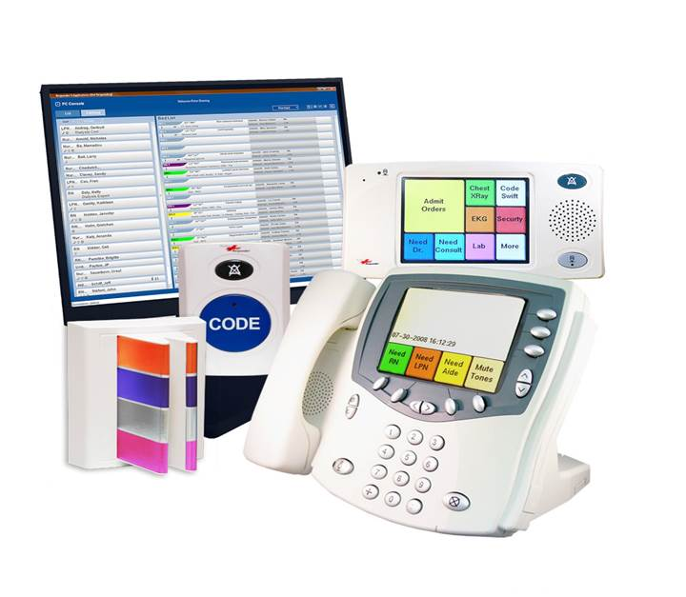

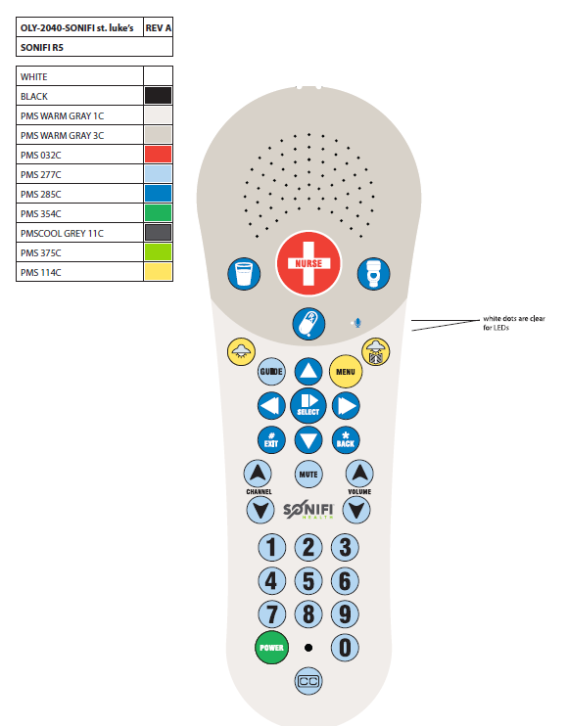

* Medication Distribution (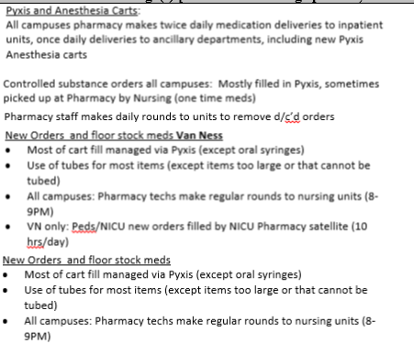
* Temperature Monitoring (See Rays)
  + We will be using Aeroscout System to monitor temperature in XXXXX . When a device’s temperature goes out of range, department will receive an alert through MobileView, if during department hours of operation. Plant Operations will receive secondary alerts, as well as primary alerts when departments are closed

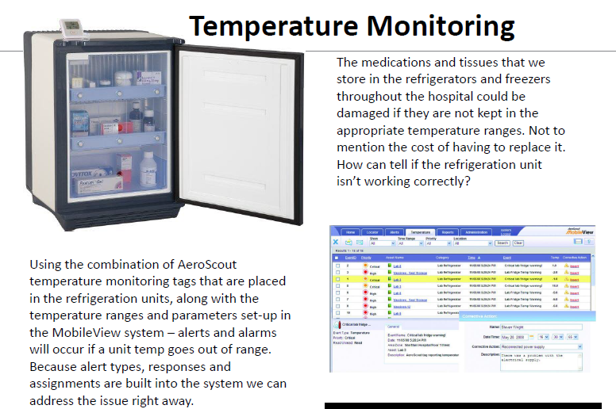

* Hand Hygiene (this is supposd to be showing up in Safety and Security section, which I have not yet seen from Sforzo or Hearn. Shall I just use this one?)
  + Through our Aeroscout Hand hygiene system, we will be able to monitor our hand hygiene compliance in patient care areas

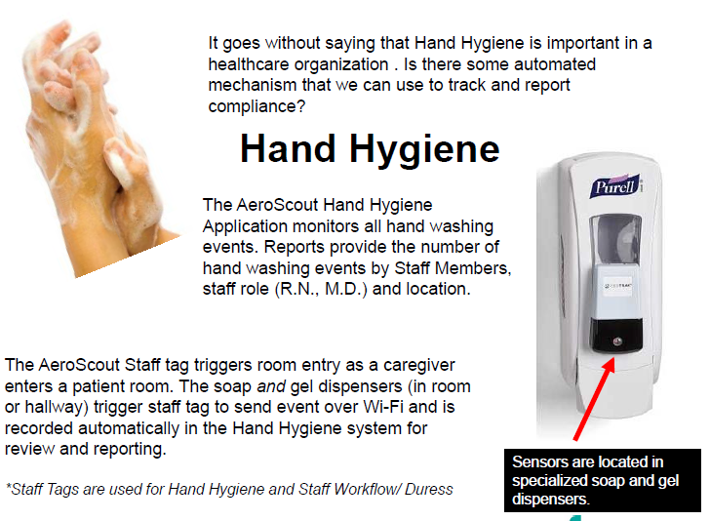

Am not sure why Staff Duress is in this section/imbedded in Hand Hygiene. Also, Staff Duress is in Safety and Security section – not yet received

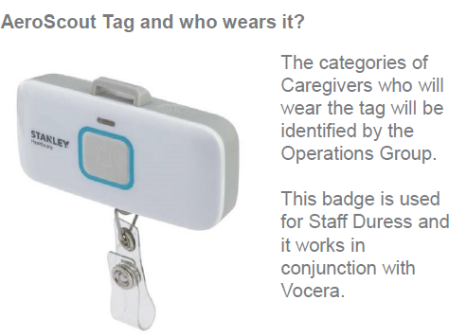

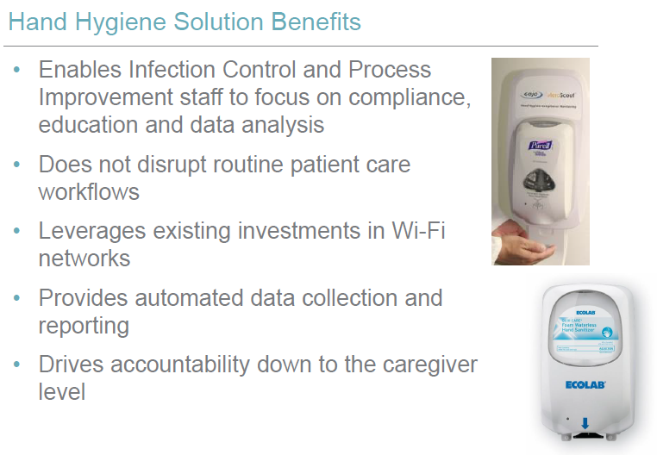

* Staff Duress (Safety and Security section to be submitted by others?)
  + Through our Aeroscout staff duress system, staff will be able to silently notify Security that they require assistance by pressing the button on their Aeroscout tag. Security will be able to locate the staff in need, via the RFID tag.
* Asset Management
  + Aeroscout RFID tags will be placed on medical equipment to assist with locating equipment for patient use.
  + This will help expedite locating equipment to facilitate patient care.
* Patient elopement prevention system
  + An Aeroscout tag will be placed on a patient, so that staff can locate a patient who is at risk of wandering
* HUGS Infant security system
  + An Aeroscout tag will be placed on an infant or child. If the infant/child travels beyond the established perimeter, the system will alarm and staff will respond to secure / locate the infant/child.
* Vocera
  + Vocera is a communication system which …WE KNOW THIS IS STILL TBD Note that NOT listed in Table of Contents
* **Patient lift system and mobile lifts**
  + We have overhead patient lift systems in all of our med/surg and ICU patient rooms, to assist with patient mobility in bed and around the room.
  + This is one of our safety features – to assist with patient mobility and reduce the risk of associated employee injuries
  + In addition, we will have mobile lifts available for use in patient care areas, to assist with patient mobility, where ceiling lifts are not available.
* **Pneumatic Tube System**
  + Our pneumatic tube system will assist with transporting medications, lab specimens and blood products to/from patient care areas, to expedite patient care.
  + Our system will have an enhanced “secure send” functionality which will only allow appropriately licensed staff to send and receive medication and blood products.

According to table of contents, this section is also supposed to incude the following:

Positive/Negative pressure rooms

HLD process (please spell out)